|  |
| --- |
| [Company name] |
| Publishing |
| [Document subtitle] |

|  |
| --- |
| Steven Renders  [Date] |

Table of Contents

Step 04 Publishing 2

Create a Power BI Account 2

Publish your .pbix 3

Create a Dashboard 7

Get Insights 8

Test Phone Layout 11

# Step 04 Publishing

You can continue to work on your previous Power BI Desktop file, or you can start with this file: Step 02 Step 04 Publishing - START.pbix

## Create a Power BI Account

Open your browser and go to:

<https://powerbi.microsoft.com/en-us/>

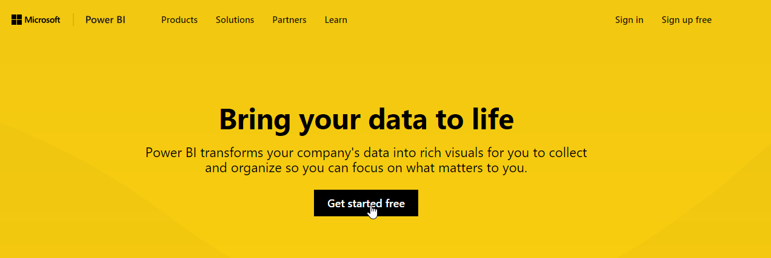

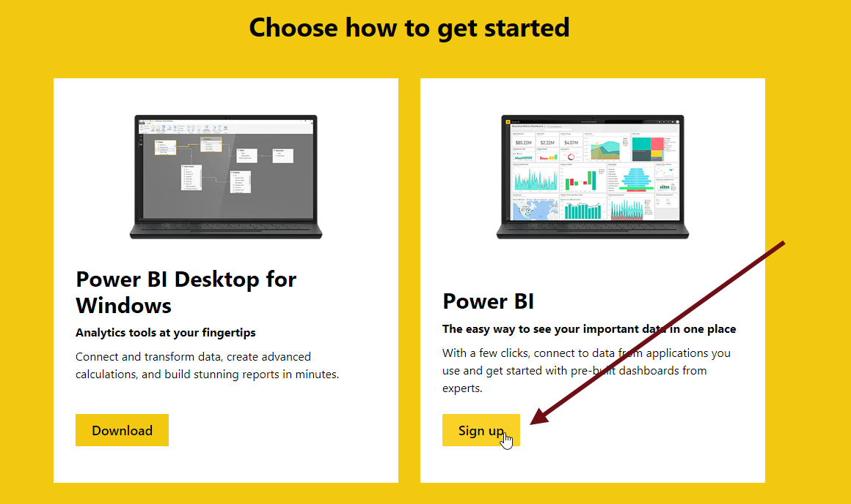

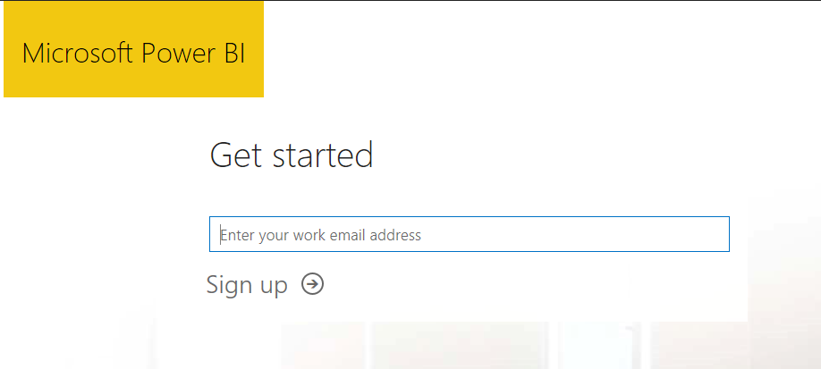

If you don’t have an account yet, enter an email address to create a free account. In case your email address is not accepted, for the purpose of this hands-on lab, you can sign up for a trial Office 365 account here:

<https://products.office.com/en-us/try>

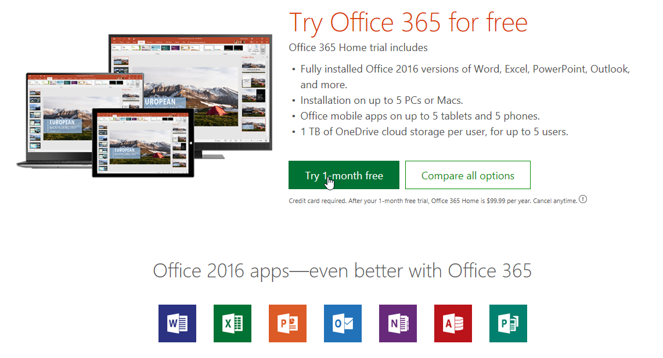

Once you have an O365 account, use that email address to sign up for Power BI.

## Publish your .pbix

In Power BI Desktop, select the Publish button:

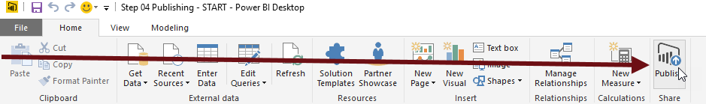

Enter the email address you used for the Power BI website:

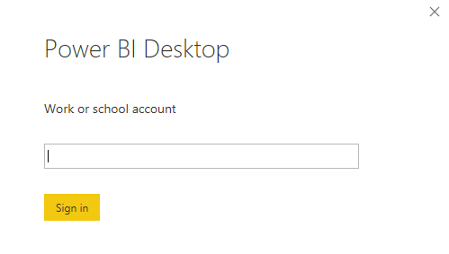

Then authenticate:

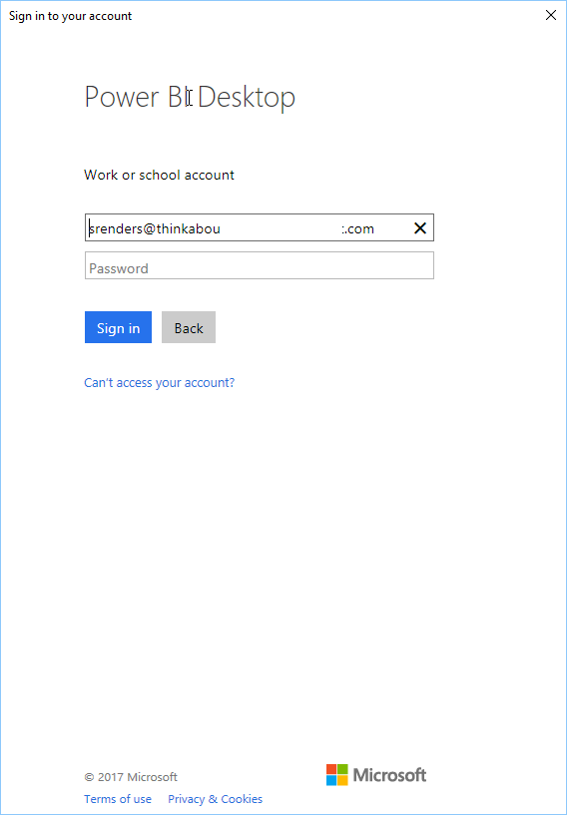

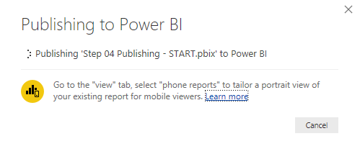

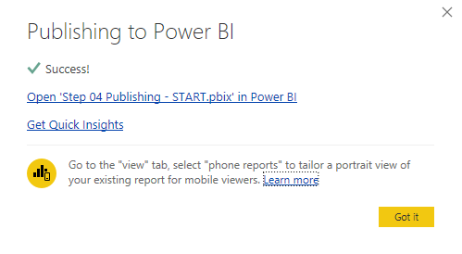

Click the link in the message, or go to the power bi website and login. You will see your report there:

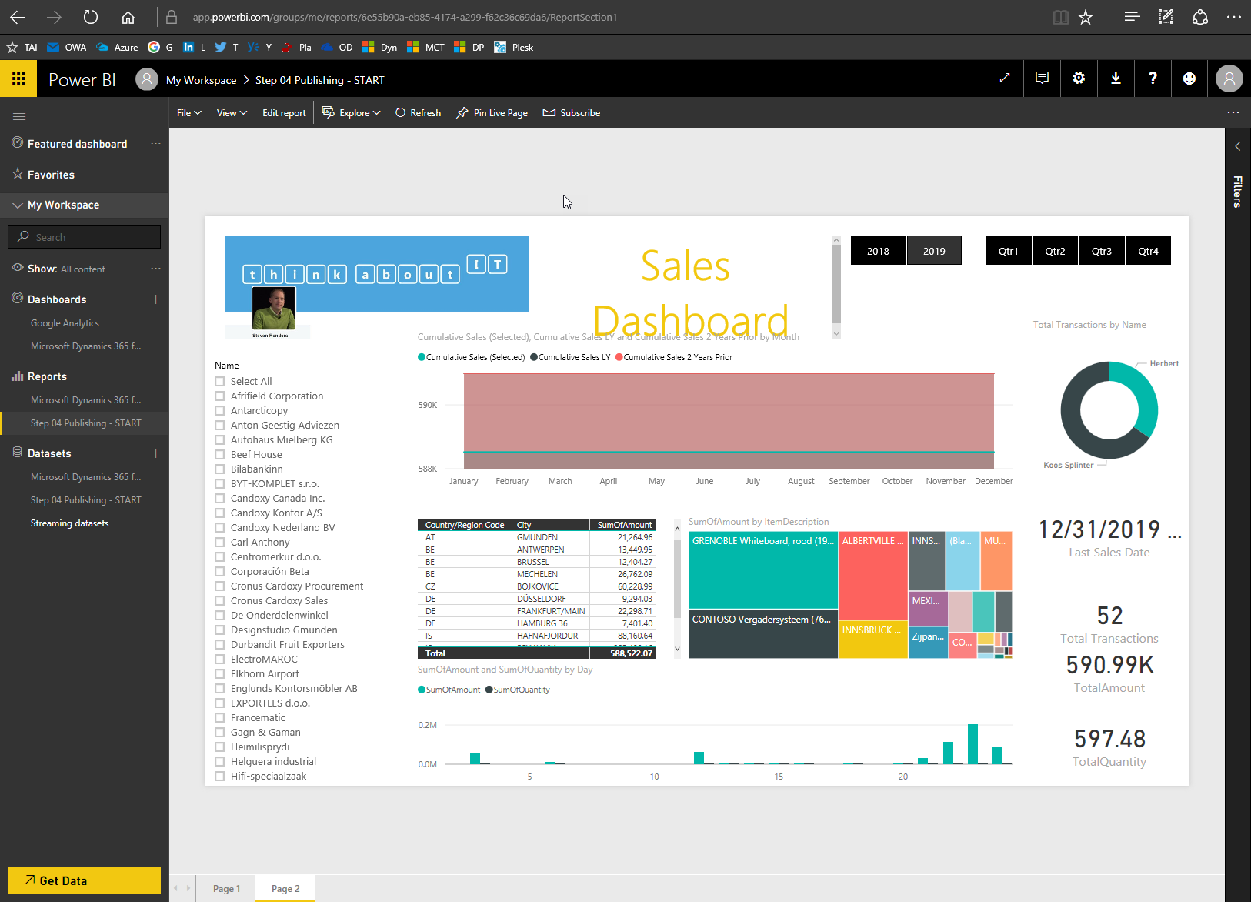

As you notice, on the website, in your browser, you can still edit the report:

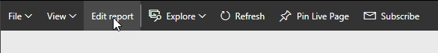

In the File menu, there are several other options:

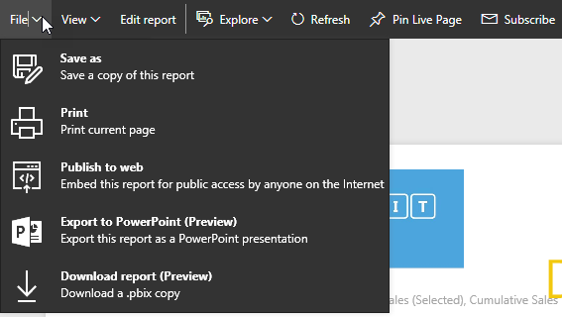

## Create a Dashboard

On any of the visuals in your report, you can use the pin icon to pin (or add) it to a dashboard:



Click it, select New Dashboard and enter a name:

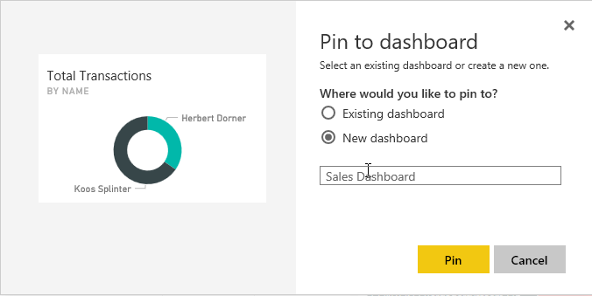

Then repeat this for other report parts you want to add to the Sales Dashboard:

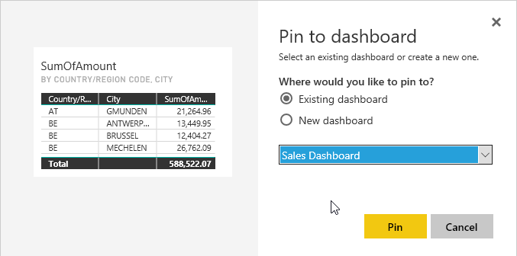

On the left side, in the menu, under Dashboards, you will now see your Sales Dashboard:

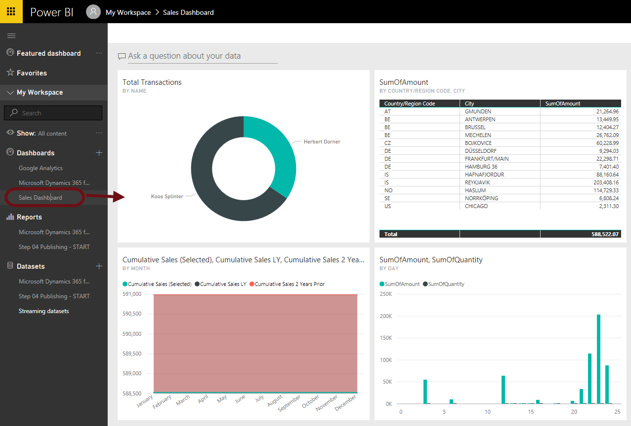

## Get Insights

Select Quick Insights on your dataset:

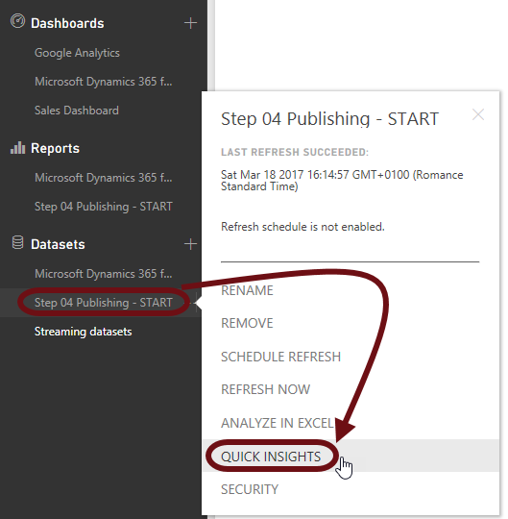

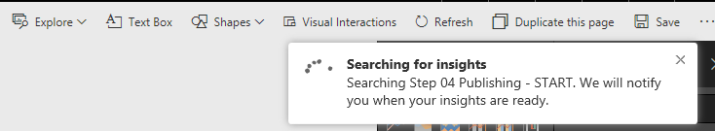

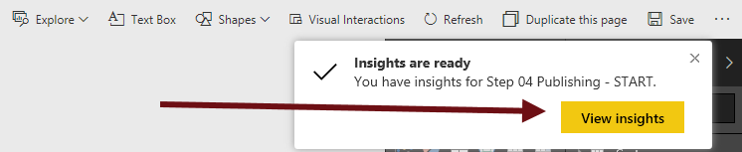

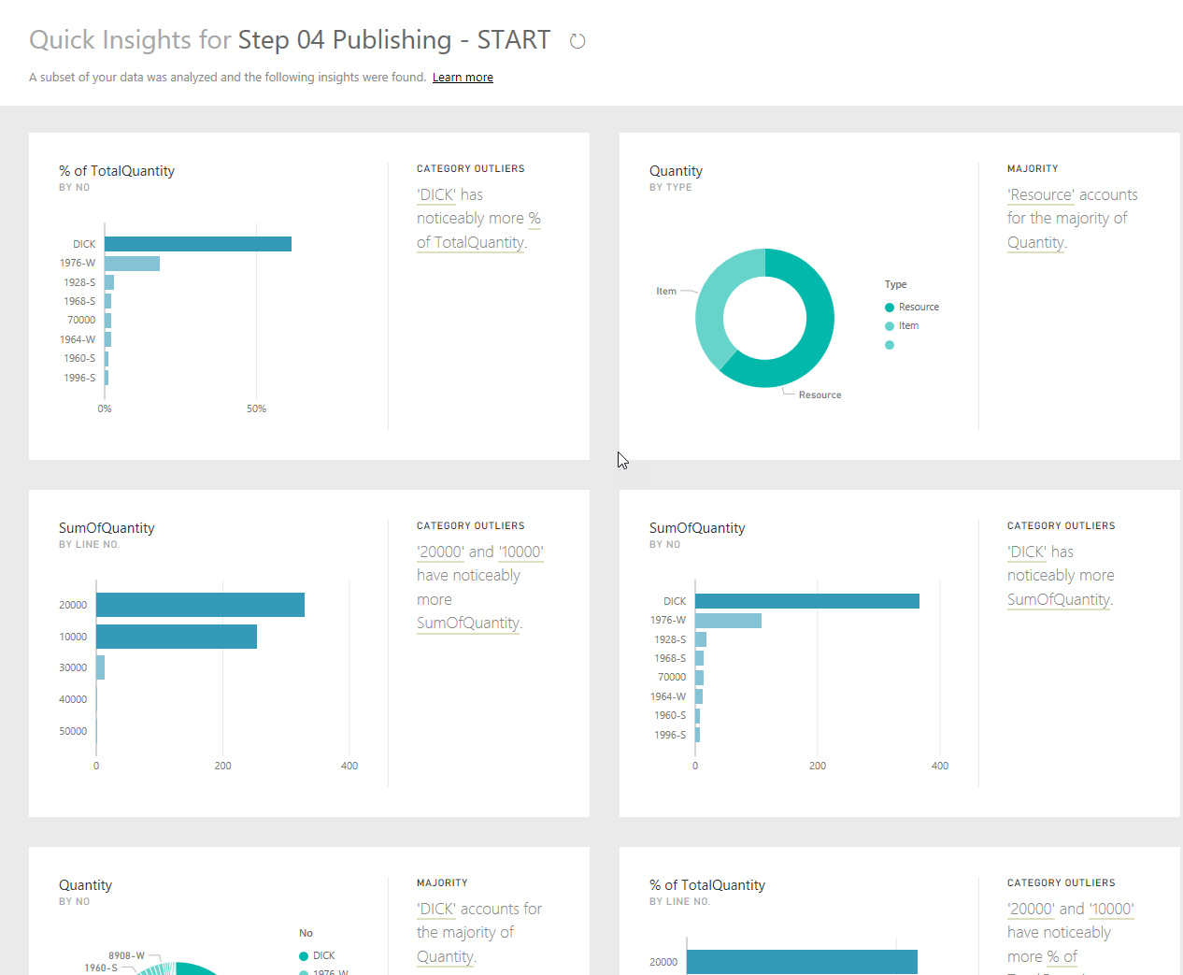

If an insight looks interesting, you can also pin it to your dashboard:

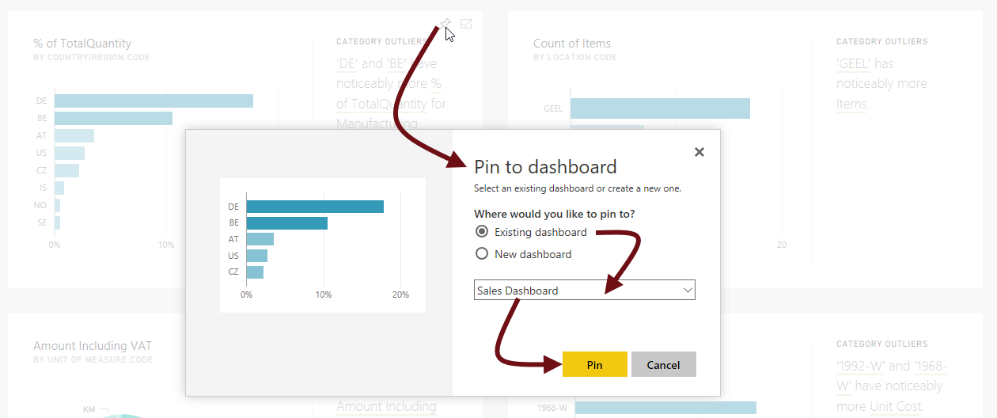

## Test Phone Layout

At the right top select the button with the three dots:

